EXP NO 5: CREATE A SIMPLE CLOUD SOFTWARE APPLICATION FOR LIBRARY BOOKING SYSTEM FOR SIMATS LIBRARY USING ANY CLOUD SERVICE PROVIDER TO DEMONSTRATE SAAS.

DATE:

AIM:

To Create a simple cloud software application for Library booking system for SIMATS library using any Cloud Service Provider to demonstrate SaaS

PROCEDURE:

Step1: Go to zoho.com.

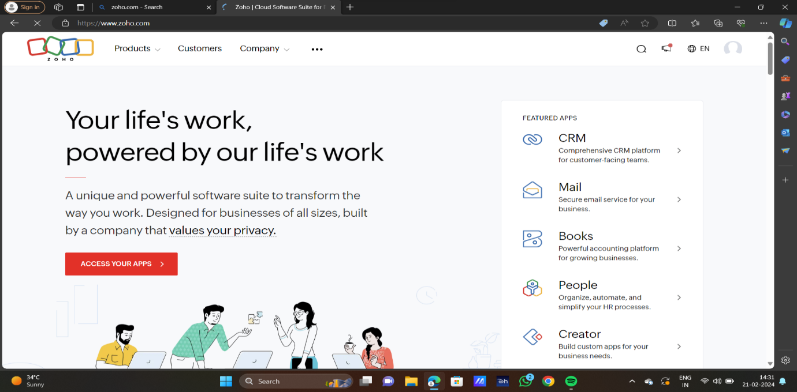

STEP2:LOG INTO THE ZOHO.COM

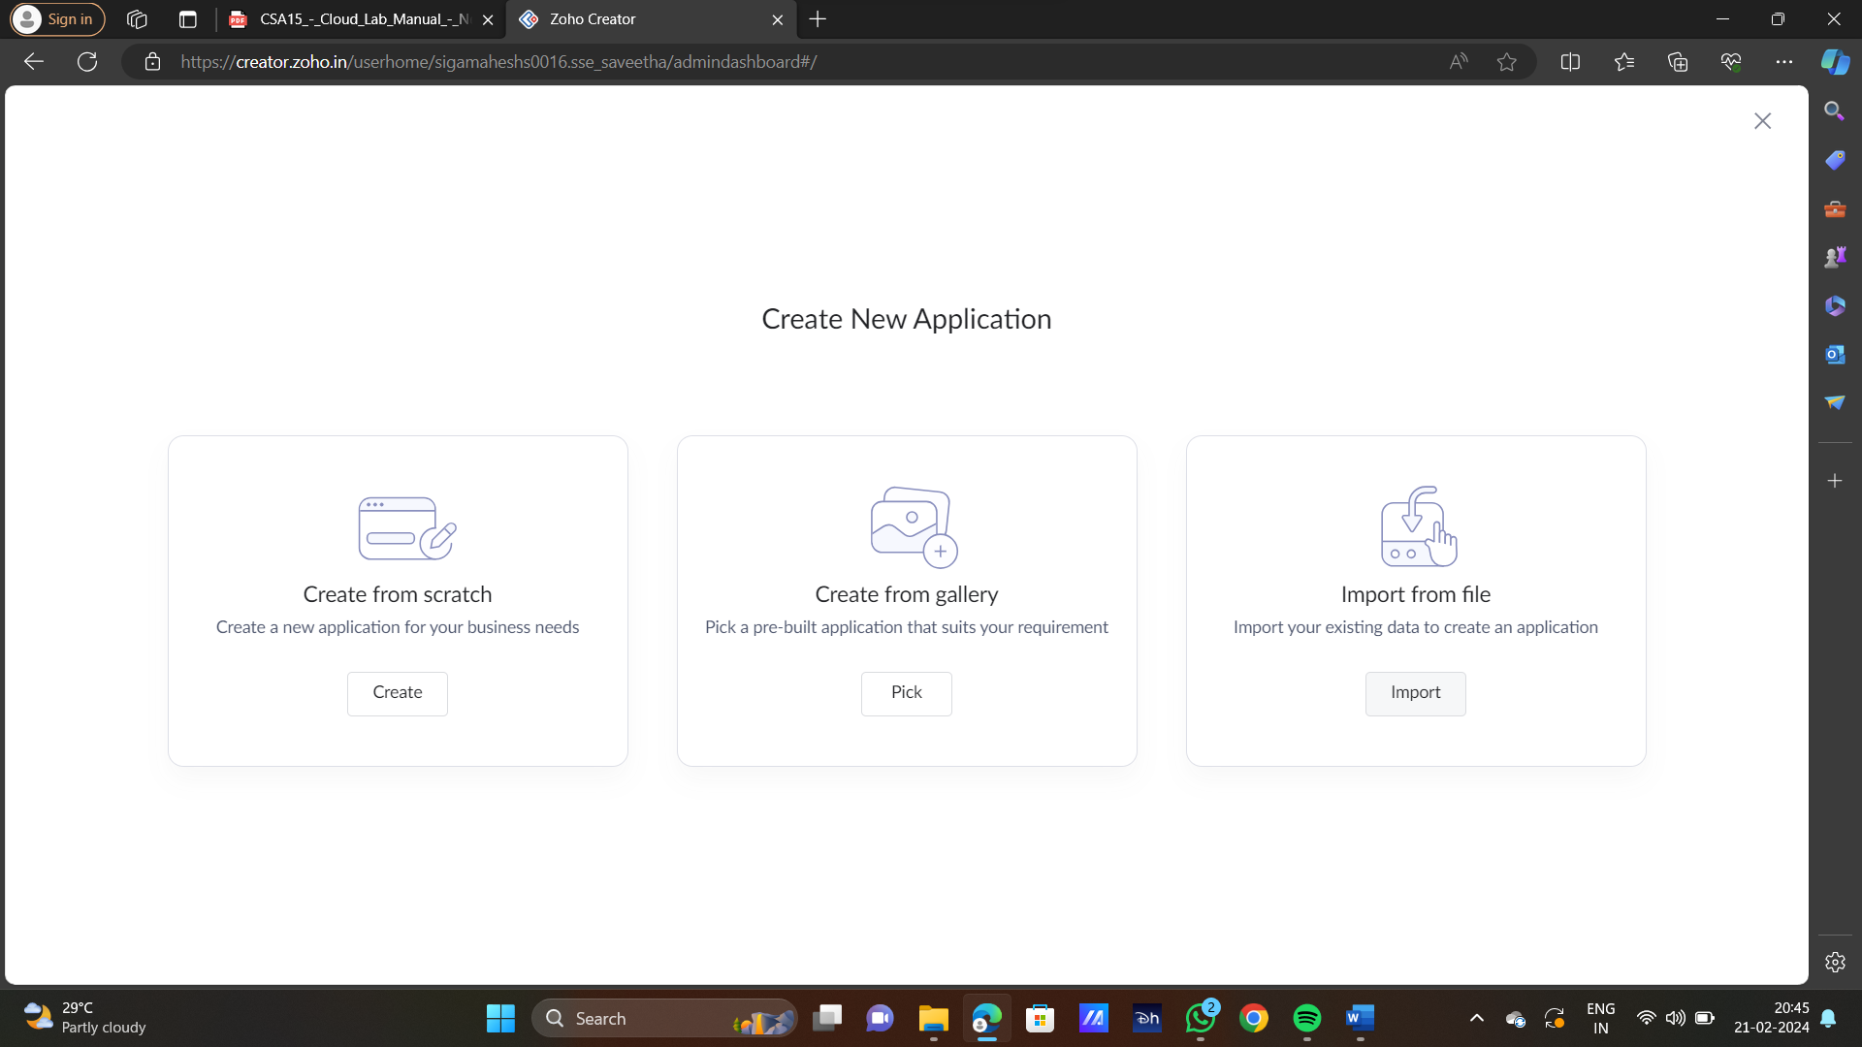

STEP3:SELECT ONE APPLICATION

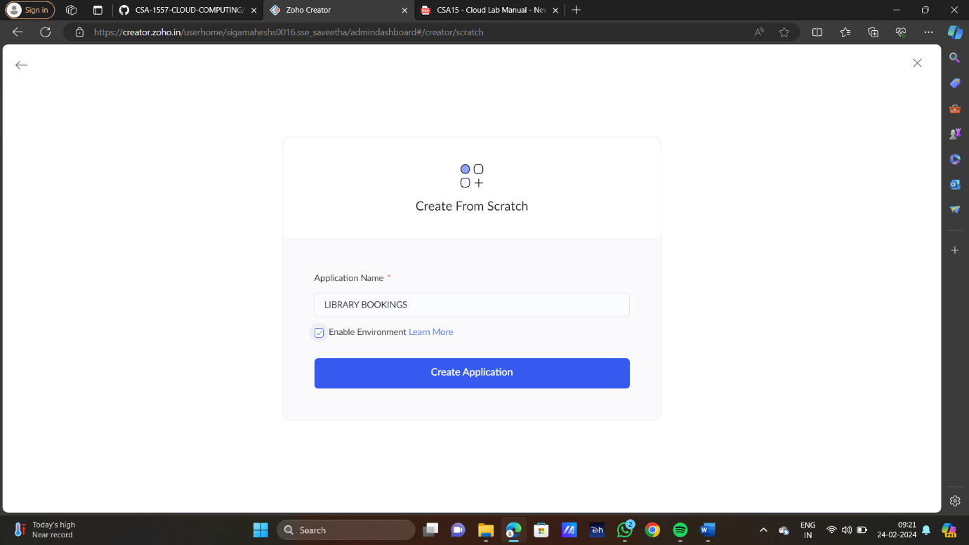

STEP4:ENTER APPLICATION NAME



STEP5:CREATED NEW APPLICATION

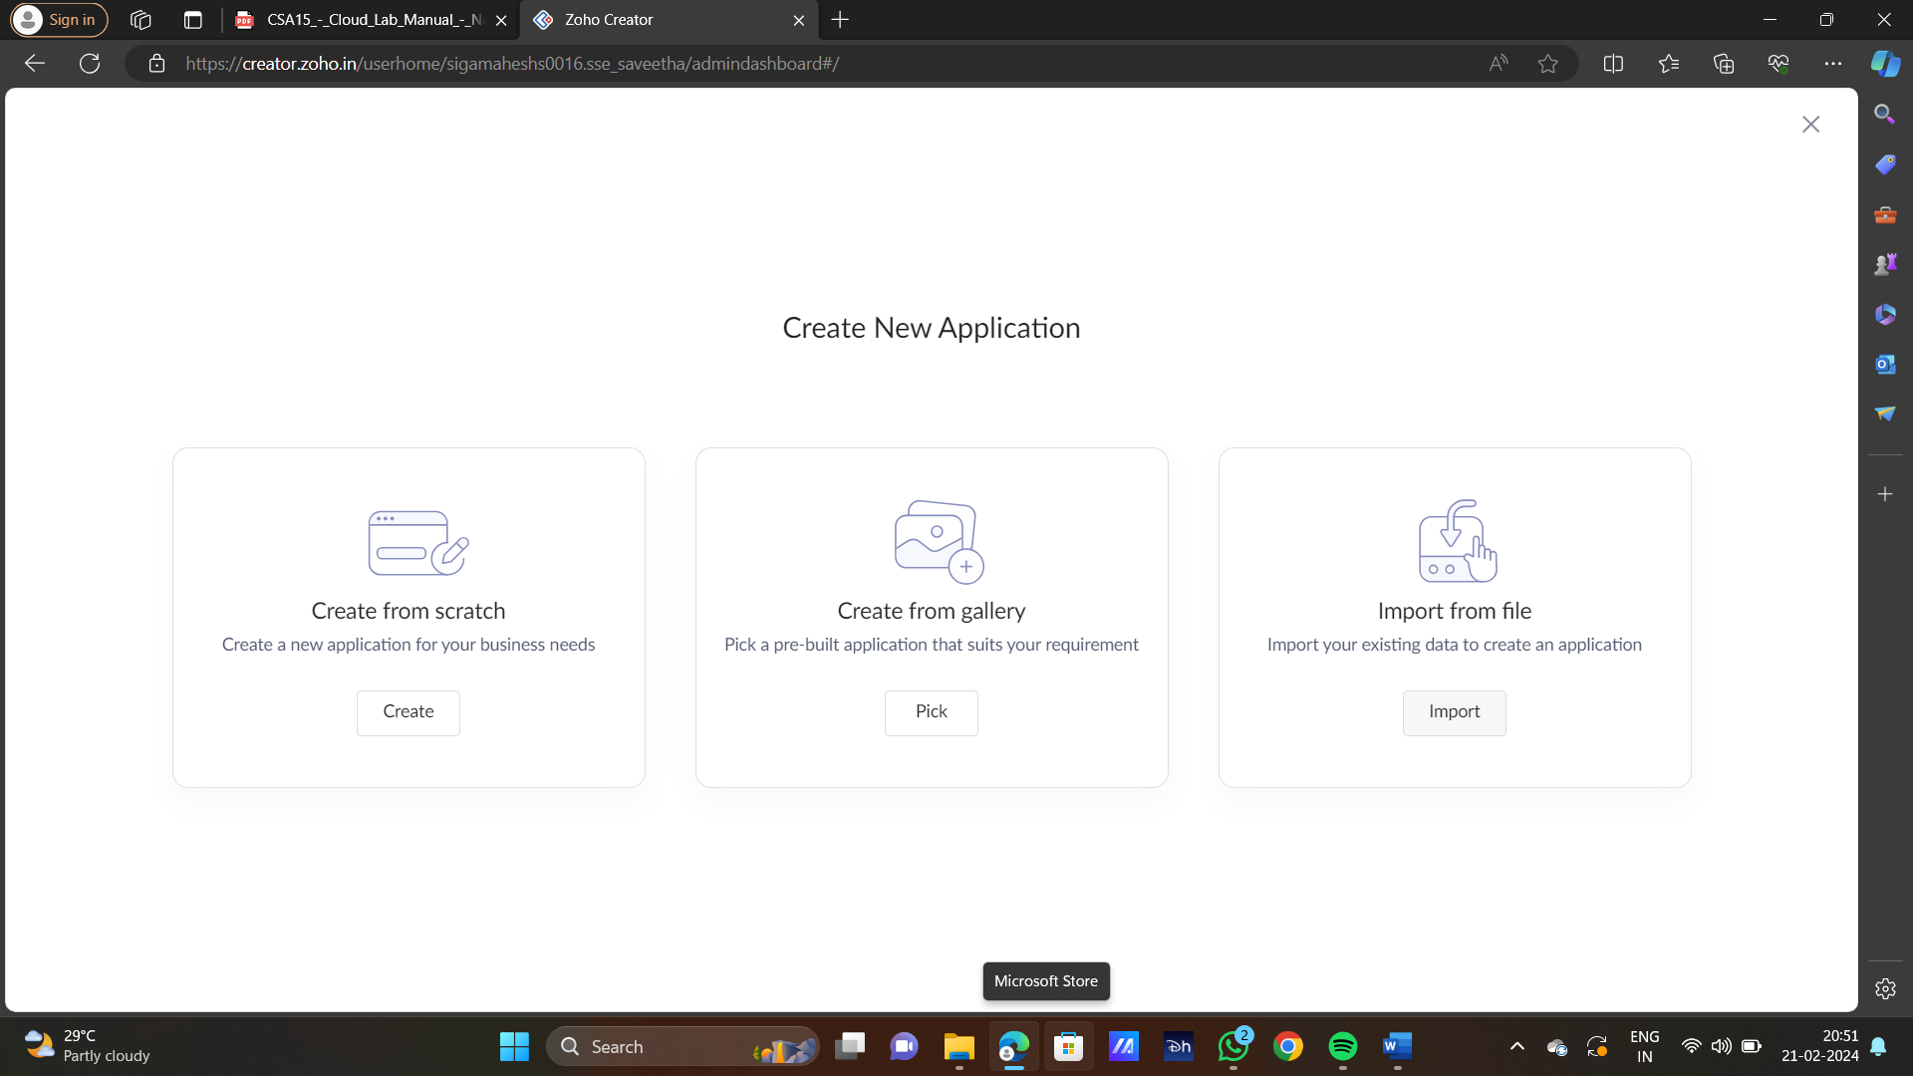

STEP6:SELECT ONE FORM

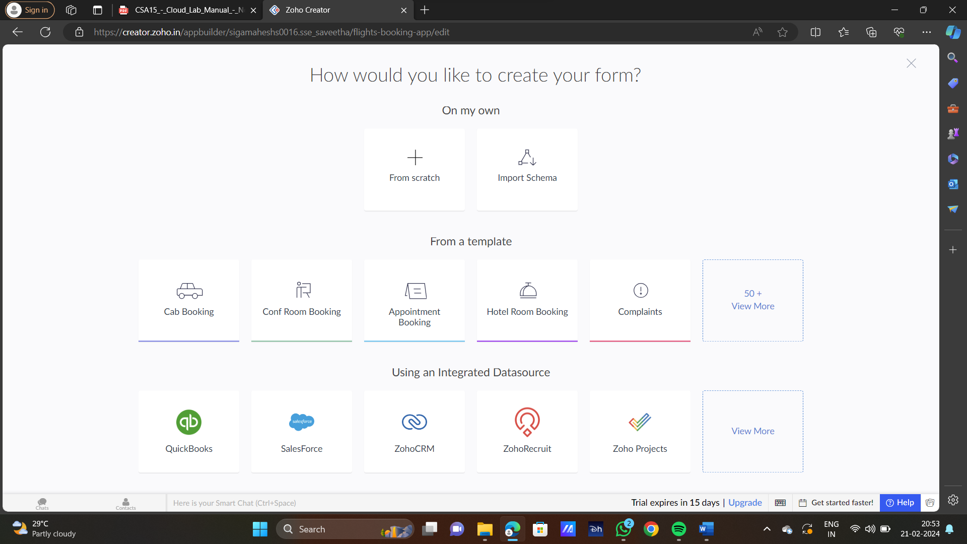

STEP7:THE SOFTWARE HAS BEEN CREATED

